UNITED STATES

SECURITIES AND EXCHANGE COMMISSION

WASHINGTON, D.C. 20549

FORM 8-K

CURRENT REPORT

PURSUANT TO SECTION 13 OR 15(d) OF

THE SECURITIES EXCHANGE ACT OF 1934

Date of Report (Date of Earliest Event Reported): May 5, 2026

Corteva, Inc.

(Exact Name of Registrant as Specified in Its Charter)

Delaware | 001-38710 | 82-4979096
(State or other jurisdiction | (Commission | (I.R.S. Employer
of Incorporation) | File Number) | Identification No.)
 | 9330 Zionsville Road,
 | Indianapolis, Indiana 46268
 | 1000 N. West Street, Suite 900,
 | Wilmington, Delaware 19801
 | (Address of principal executive offices)(Zip Code)
 | (833) 267-8382
 | (Registrant’s telephone number, including area code)

Check the appropriate box below if the Form 8-K filing is intended to simultaneously satisfy the filing obligation of the registrant under any of the following provisions:

- Written communications pursuant to Rule 425 under the Securities Act (17 CFR 230.425)

- Soliciting material pursuant to Rule 14a-12 under the Exchange Act (17 CFR 240.14a-12)

- Pre-commencement communications pursuant to Rule 14d-2(b) under the Exchange Act (17 CFR 240.14d-2(b))

- Pre-commencement communications pursuant to Rule 13e-4(c) under the Exchange Act (17 CFR 240.13e-4(c)) Securities registered pursuant to Section 12(b) of the Act:
Title of each class |  | Trading Symbol(s) |  | Name of each exchange on which
 |  |  |  | registered
Common Stock, par value $0.01 per share |  | CTVA |  | New York Stock Exchange

Indicate by check mark whether the registrant is an emerging growth company as defined in Rule 405 of the Securities Act of 1933 (§230.405 of this chapter) or Rule 12b-2 of the Securities Exchange Act of 1934 (§240.12b-2 of this chapter).

Emerging growth company ☐

If an emerging growth company, indicate by check mark if the registrant has elected not to use the extended transition period for complying with any new or revised financial accounting standards provided pursuant to Section 13(a) of the Exchange Act. o

Item 2.02 Results of Operations and Financial Condition

On May 5, 2026, Corteva, Inc. (the “Company”) announced its consolidated financial results for the quarter ended March 31, 2026. A copy of the Company’s press release and financial statement schedules are furnished herewith on Form 8-K as Exhibits 99.1 and 99.2, respectively. The information contained in this report, including Exhibits 99.1 and 99.2, is being furnished and shall not be deemed “filed” for purposes of Section 18 of the Securities Exchange Act of 1934, as amended (the “Exchange Act”), or otherwise subject to the liability of that section. In addition, the information contained in this report shall not be deemed to be incorporated by reference into any registration statement or other document filed by the Company under the Securities Act of 1933, as amended, or the Exchange Act except as expressly set forth by specific reference in such filing.

Item 9.01 Financial Statements and Exhibits

(d) Exhibits.
99.1 |  |  | Press Release dated May 5, 2026
99.2 |  |  | Financial Statement Schedules dated May 5, 2026
 | 104 |  | The cover page from the Company’s Current Report on Form 8-K, formatted in Inline XBRL

SIGNATURE

Pursuant to the requirements of the Securities Exchange Act of 1934, the Registrant has duly caused this report to be signed on its behalf by the undersigned hereunto duly authorized.

Corteva, Inc.

(Registrant)

/s/ Brian Titus

Brian Titus

Vice President and Controller

May 5, 2026

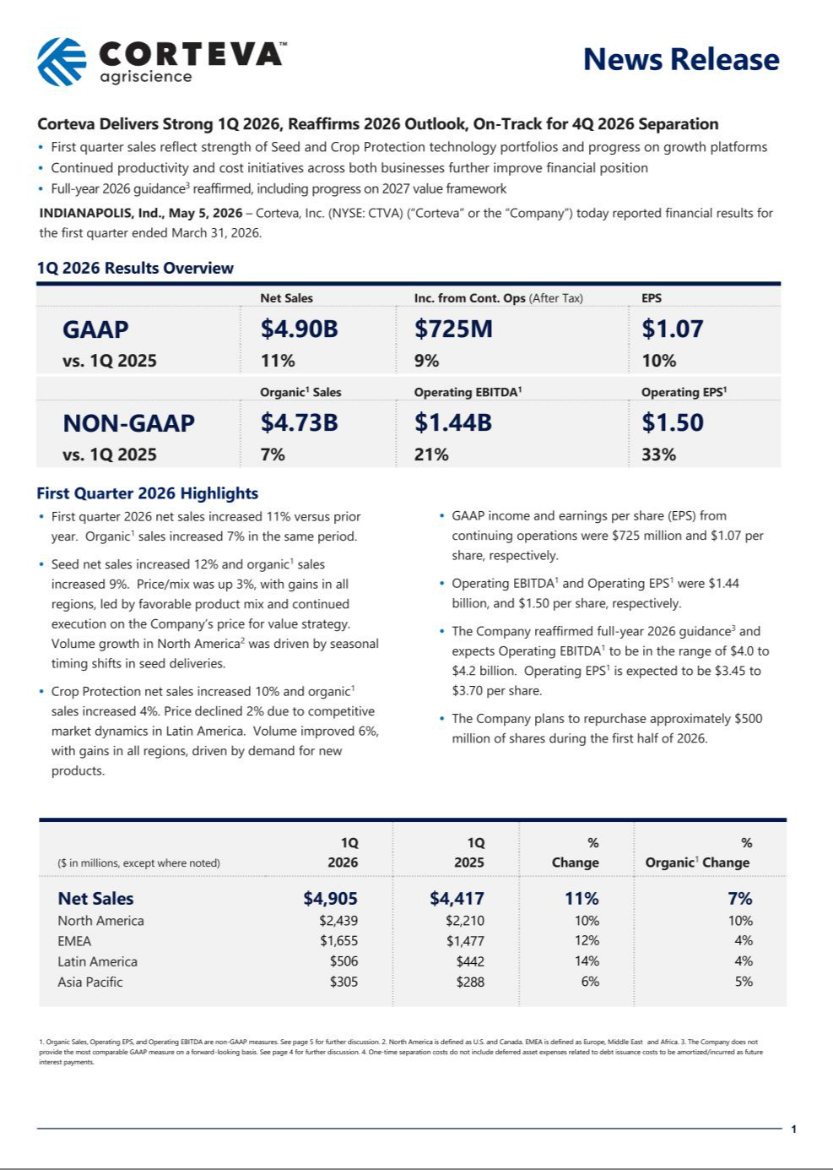

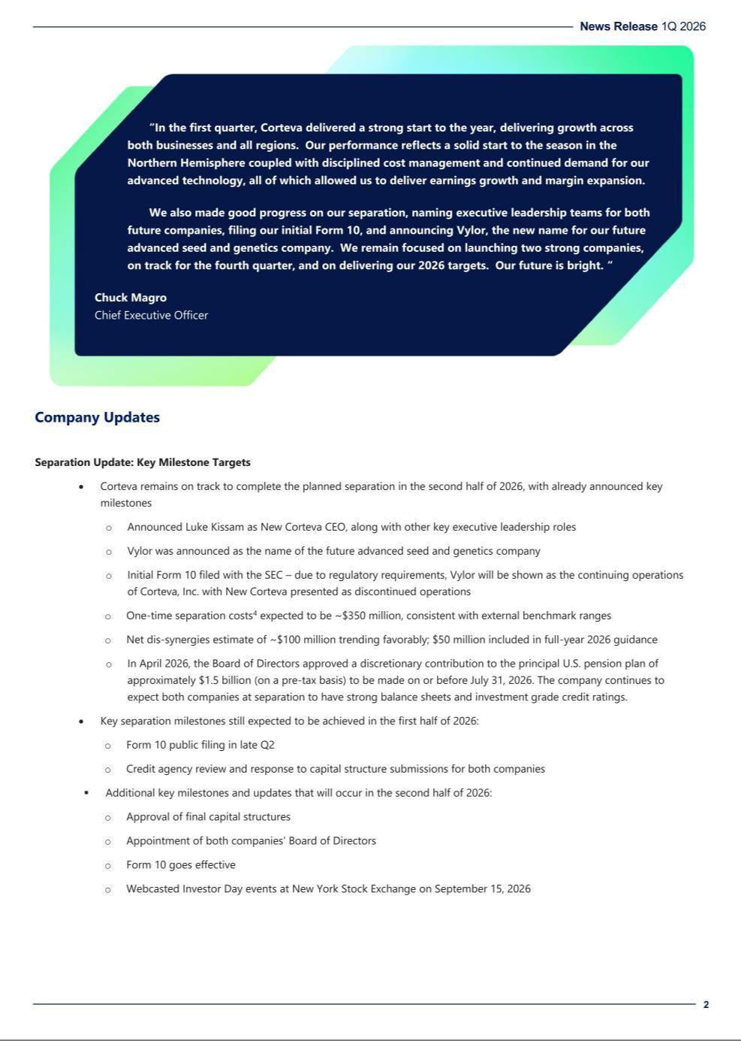

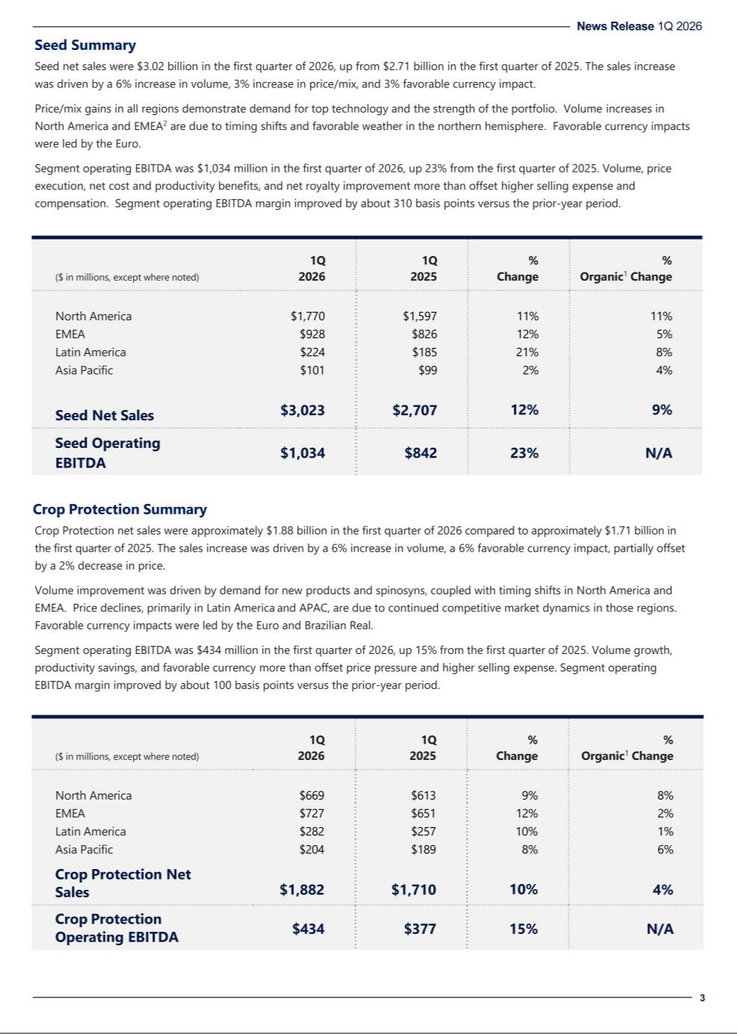

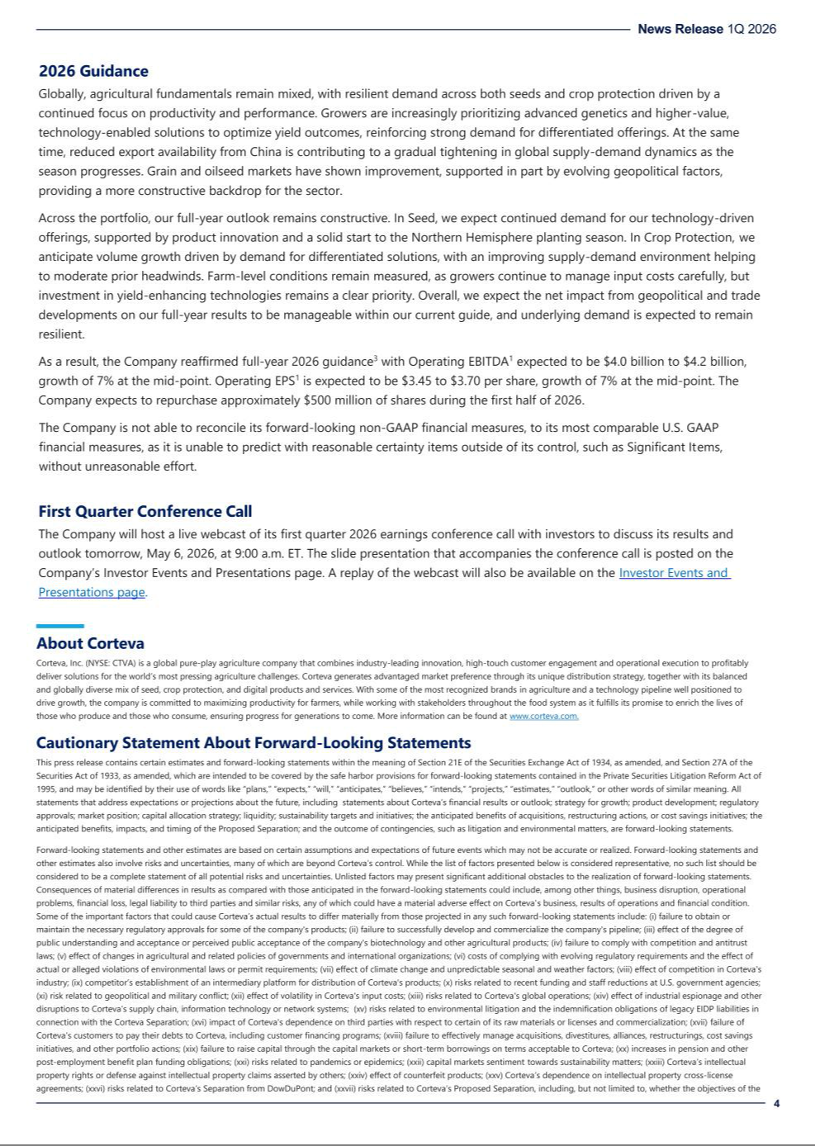

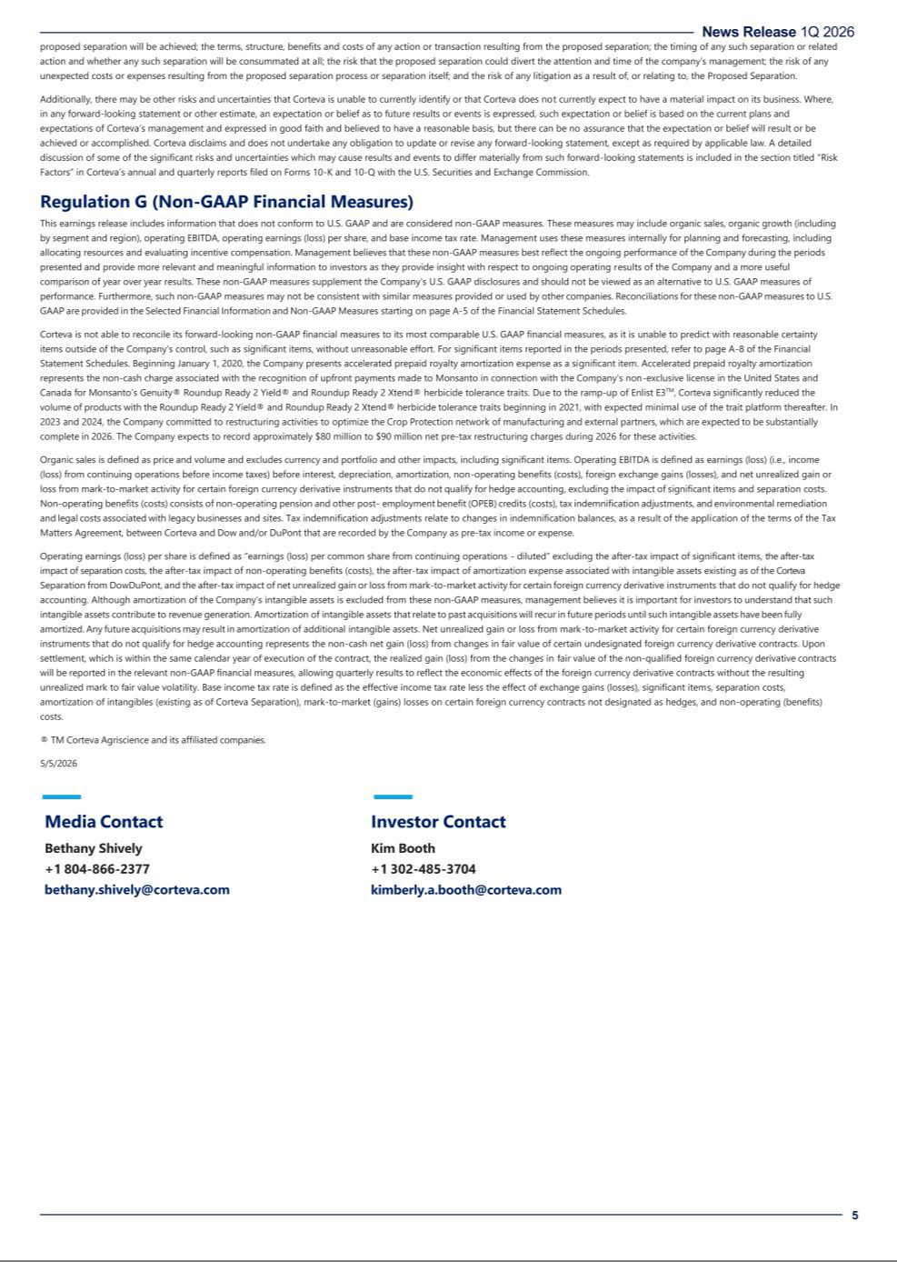

A-1

Corteva, Inc.
Consolidated Statements of Operations

(Dollars in millions, except per share amounts)

Three Months Ended
March 31,
 | 2026 |  |  |  | 2025
Net sales | $ | 4,905 |  | $ | 4,417
Cost of goods sold |  | 2,372 |  |  | 2,342
Research and development expense |  | 341 |  |  | 335
Selling, general and administrative expenses |  | 877 |  |  | 751
Amortization of intangibles |  | 160 |  |  | 162
Restructuring and asset related charges - net |  | 92 |  |  | 22
Separation costs |  | 52 |  |  | —
Other income (expense) - net |  | (117) |  |  | 15
Interest expense |  | 36 |  |  | 36
Income (loss) from continuing operations before income taxes |  | 858 |  |  | 784
Provision for (benefit from) income taxes on continuing operations |  | 133 |  |  | 117
Income (loss) from continuing operations after income taxes |  | 725 |  |  | 667
Income (loss) from discontinued operations after income taxes |  | (2) |  |  | (11)
Net income (loss) |  | 723 |  |  | 656
Net income (loss) attributable to noncontrolling interests |  | 3 |  |  | 4
Net income (loss) attributable to Corteva | $ | 720 |  | $ | 652
Basic earnings (loss) per share of common stock:
Basic earnings (loss) per share of common stock from continuing operations | $ | 1.07 |  | $ | 0.97
Basic earnings (loss) per share of common stock from discontinued operations |  | — |  |  | (0.02)
Basic earnings (loss) per share of common stock | $ | 1.07 |  | $ | 0.95
Diluted earnings (loss) per share of common stock:
Diluted earnings (loss) per share of common stock from continuing operations | $ | 1.07 |  | $ | 0.97
Diluted earnings (loss) per share of common stock from discontinued operations |  | — |  |  | (0.02)
Diluted earnings (loss) per share of common stock | $ | 1.07 |  | $ | 0.95
Average number of shares outstanding used in earnings (loss) per share (EPS) calculation (in millions)
Basic |  | 672.5 |  |  | 684.9
Diluted |  | 673.6 |  |  | 686.6

A-2

Corteva, Inc.
Consolidated Balance Sheets

(Dollars in millions, except share amounts)

 |  | March 31, 2026 |  |  |  | December 31, 2025 |  |  | March 31, 2025
 | Assets
Current assets
Cash and cash equivalents | $ |  | 1,964 |  | $ | 4,521 |  | $ | 2,008
Marketable securities |  |  | 2 |  |  | 9 |  |  | 1
Accounts and notes receivable - net |  |  | 9,088 |  |  | 6,371 |  |  | 8,294
Inventories |  |  | 5,202 |  |  | 5,667 |  |  | 5,132
Other current assets |  |  | 1,129 |  |  | 767 |  |  | 1,152

Total current assets |  | 17,385 |  |  | 17,335 |  |  | 16,587
Investment in nonconsolidated affiliates |  | 165 |  |  | 160 |  |  | 136
Property, plant and equipment |  | 9,617 |  |  | 9,551 |  |  | 9,244
Less: Accumulated depreciation |  | 5,434 |  |  | 5,331 |  |  | 5,139
Net property, plant and equipment |  | 4,183 |  |  | 4,220 |  |  | 4,105
Goodwill |  | 10,409 |  |  | 10,465 |  |  | 10,332
Other intangible assets |  | 8,147 |  |  | 8,301 |  |  | 8,718
Deferred income taxes |  | 395 |  |  | 320 |  |  | 413
Other assets |  | 2,033 |  |  | 2,044 |  |  | 1,832
Total Assets | $ | 42,717 |  | $ | 42,845 |  | $ | 42,123
Liabilities and Equity
Current liabilities
Short-term borrowings | $ | 1,674 |  | $ | 894 |  | $ | 2,291
Accounts payable |  | 4,187 |  |  | 4,398 |  |  | 3,905
Income taxes payable |  | 229 |  |  | 155 |  |  | 322
Deferred revenue |  | 2,773 |  |  | 3,579 |  |  | 2,631
Accrued and other current liabilities |  | 2,991 |  |  | 3,099 |  |  | 2,332
Total current liabilities |  | 11,854 |  |  | 12,125 |  |  | 11,481
Long-term debt |  | 1,682 |  |  | 1,686 |  |  | 1,792
Other noncurrent liabilities
Deferred income tax liabilities |  | 290 |  |  | 251 |  |  | 369
Pension and other post-employment benefits |  | 2,388 |  |  | 2,434 |  |  | 2,239
Other noncurrent obligations |  | 1,898 |  |  | 1,963 |  |  | 1,715
Total noncurrent liabilities |  | 6,258 |  |  | 6,334 |  |  | 6,115
Commitments and contingent liabilities
Stockholders' equity
Common stock, $0.01 par value; 1,666,667,000 shares authorized; issued at March 31, 2026 - |  | 7 |  |  | 7 |  |  | 7
670,044,000; December 31, 2025 - 672,163,000; and March 31, 2025 - 683,026,000 |  | 7 |  |  | 7 |  |  | 7
Additional paid-in capital |  | 26,859 |  |  | 27,001 |  |  | 26,962
Retained earnings (accumulated deficit) |  | 436 |  |  | (67) |  |  | 587
Accumulated other comprehensive income (loss) |  | (2,940) |  |  | (2,797) |  |  | (3,271)
Total Corteva stockholders' equity |  | 24,362 |  |  | 24,144 |  |  | 24,285
Noncontrolling interests |  | 243 |  |  | 242 |  |  | 242
Total equity |  | 24,605 |  |  | 24,386 |  |  | 24,527
Total Liabilities and Equity | $ | 42,717 |  | $ | 42,845 |  | $ | 42,123

A-3

Corteva, Inc.
Consolidated Statements of Cash Flows

(Dollars in millions, except per share amounts)

Three Months Ended
March 31,
 | 2026 |  |  |  | 2025
Operating activities
Net income (loss) | $ | 723 |  | $ | 656
(Income) loss from discontinued operations after income taxes |  | 2 |  |  | 11
Adjustments to reconcile net income (loss) to cash provided by (used for) operating activities:
Depreciation and amortization |  | 297 |  |  | 296
Provision for (benefit from) deferred income tax |  | (52) |  |  | (122)
Net periodic pension and OPEB (benefit) cost, net |  | (3) |  |  | 10
Pension and OPEB contributions |  | (48) |  |  | (51)
Net (gain) loss on sales of property, businesses, consolidated companies and investments |  | 3 |  |  | (4)
Restructuring and asset related charges - net |  | 92 |  |  | 22
Other net loss |  | 157 |  |  | 75
Changes in assets and liabilities, net
Accounts and notes receivable |  | (2,810) |  |  | (2,505)
Inventories |  | 439 |  |  | 379
Accounts payable |  | (221) |  |  | (190)
Deferred revenue |  | (790) |  |  | (667)
Other assets and liabilities |  | (674) |  |  | (11)
Cash provided by (used for) operating activities - continuing operations | $ | (2,885) |  | $ | (2,101)
Cash provided by (used for) operating activities - discontinued operations |  | (6) |  |  | (8)
Cash provided by (used for) operating activities | $ | (2,891) |  | $ | (2,109)
Investing activities
Capital expenditures | $ | (81) |  | $ | (94)
Proceeds from sales of property, businesses and consolidated companies - net of cash divested |  | — |  |  | 8
Investments in and loans to nonconsolidated affiliates |  | (3) |  |  | —
Proceeds from sales and maturities of investments |  | 8 |  |  | 62
Other investing activities, net |  | (1) |  |  | (10)
Cash provided by (used for) investing activities | $ | (77) |  | $ | (34)
Financing activities
Net change in borrowings (less than 90 days) | $ | 521 |  | $ | 745
Proceeds from debt |  | 268 |  |  | 637
Payments on debt |  | (22) |  |  | (14)
Repurchase of common stock |  | (250) |  |  | (270)
Proceeds from exercise of stock options |  | 17 |  |  | 35
Dividends paid to stockholders |  | (121) |  |  | (116)
Other financing activities, net |  | (24) |  |  | (22)
Cash provided by (used for) financing activities | $ | 389 |  | $ | 995
Effect of exchange rate changes on cash, cash equivalents and restricted cash equivalents |  | (5) |  |  | 21
Increase (decrease) in cash, cash equivalents and restricted cash equivalents | $ | (2,584) |  | $ | (1,127)
Cash, cash equivalents and restricted cash equivalents at beginning of period |  | 4,725 |  |  | 3,422
Cash, cash equivalents and restricted cash equivalents at end of period | $ | 2,141 |  | $ | 2,295

A-4

Corteva, Inc.
Consolidated Segment Information

(Dollars in millions, except per share amounts)

 |  |  | Three Months Ended
 |  |  | March 31,
SEGMENT NET SALES - SEED |  |  | 2026 |  |  | 2025
Corn |  | $ | 2,373 |  | $ | 2,069
Soybean |  |  | 306 |  |  | 305
Other oilseeds |  |  | 245 |  |  | 223
Other |  |  | 99 |  |  | 110
Seed |  | $ | 3,023 |  | $ | 2,707

 |  |  | Three Months Ended
 |  |  | March 31,
SEGMENT NET SALES - CROP PROTECTION |  |  | 2026 |  |  | 2025
Herbicides |  | $ | 1,027 |  | $ | 860
Insecticides |  |  | 377 |  |  | 336
Fungicides |  |  | 334 |  |  | 304
Biologicals |  |  | 70 |  |  | 84
Other |  |  | 74 |  |  | 126
Crop Protection |  | $ | 1,882 |  | $ | 1,710

 |  |  | Three Months Ended
 |  |  | March 31,
GEOGRAPHIC NET SALES - SEED |  |  | 2026 |  |  | 2025
North America ¹ |  | $ | 1,770 |  | $ | 1,597
EMEA ² |  |  | 928 |  |  | 826
Latin America |  |  | 224 |  |  | 185
Asia Pacific |  |  | 101 |  |  | 99
Rest of World ³ |  |  | 1,253 |  |  | 1,110
Net Sales |  | $ | 3,023 |  | $ | 2,707

 |  |  | Three Months Ended
 |  |  | March 31,
GEOGRAPHIC NET SALES - CROP PROTECTION |  |  | 2026 |  |  | 2025
North America ¹ |  | $ | 669 |  | $ | 613
EMEA ² |  |  | 727 |  |  | 651
Latin America |  |  | 282 |  |  | 257
Asia Pacific |  |  | 204 |  |  | 189
Rest of World ³ |  |  | 1,213 |  |  | 1,097
Net Sales |  | $ | 1,882 |  | $ | 1,710

- Reflects U.S. & Canada

- Reflects Europe, Middle East, and Africa

- Reflects EMEA, Latin America, and Asia Pacific

A-5

Corteva, Inc.
Reconciliation of Non-GAAP Measures

(Dollars in millions, except per share amounts)

Net Sales (GAAP)

Add: Impacts from Currency and Portfolio / Other

Organic Sales (Non-GAAP)

 | Three Months Ended
 | March 31,
 | 2026
$ | 4,905
 | (179)
$ | 4,726

 |  |  | Three Months Ended
 |  |  | March 31,
OPERATING EBITDA |  |  | 2026 |  |  | 2025
Seed |  | $ | 1,034 |  | $ | 842
Crop Protection |  |  | 434 |  |  | 377
Corporate Expenses |  |  | (30) |  |  | (30)
Operating EBITDA (Non-GAAP) |  | $ | 1,438 |  | $ | 1,189

 |  |  | Three Months Ended
 |  |  | March 31,
RECONCILIATION OF INCOME (LOSS) FROM CONTINUING OPERATIONS AFTER INCOME TAXES TO OPERATING EBITDA |  |  | 2026 |  |  | 2025
Income (loss) from continuing operations after income taxes (GAAP) |  | $ | 725 |  | $ | 667
Provision for (benefit from) income taxes on continuing operations |  |  | 133 |  |  | 117
Income (loss) from continuing operations before income taxes (GAAP) |  |  | 858 |  |  | 784
Depreciation and amortization |  |  | 297 |  |  | 296
Interest income |  |  | (34) |  |  | (32)
Interest expense |  |  | 36 |  |  | 36
Exchange (gains) losses - net ¹ |  |  | 67 |  |  | 27
Non-operating (benefits) costs - net ² |  |  | (18) |  |  | 10
Mark-to-market (gains) losses on certain foreign currency contracts not designated as hedges |  |  | 3 |  |  | 9
Significant items (benefit) charge ³ |  |  | 177 |  |  | 59
Separation costs |  |  | 52 |  |  | —
Operating EBITDA (Non-GAAP) |  | $ | 1,438 |  | $ | 1,189

- Refer to page A-12 for pre-tax and after tax impacts of exchange (gains) losses.

- Non-operating (benefits) costs consists of non-operating pension and other post-employment benefit (OPEB) (credits) costs, tax indemnification adjustments and environmental remediation and legal costs associated with legacy businesses and sites. Tax indemnification adjustments relate to changes in indemnification balances, as a result of the application of the terms of the Tax Matters Agreement, between Corteva and Dow and/or DuPont that are recorded by the company as pre-tax income or expense.
- Refer to page A-8 for pre-tax and after tax impacts of significant items.

A-6

Corteva, Inc.
Reconciliation of Non-GAAP Measures

(Dollars in millions, except per share amounts)

 | PRICE - VOLUME - CURRENCY ANALYSIS
 | REGION
 |  |  |  |  |  |  | Q1 2026 vs. Q1 2025 |  |  |  |  | Percent Change Due To:
 |  |  |  |  |  | Net Sales Change |  |  | Organic Change ¹ |  | Price & |  |  | Portfolio /
 |  |  |  |  |  | (GAAP) |  |  | (Non-GAAP) |  | Price & |  |  | Portfolio /
 |  |  |  |  | $ | % |  | $ | % |  | Product Mix | Volume | Currency | Other
 | North America |  |  |  | $ | 229 |  | 10 % $ | 221 | 10 % | 1 % | 9 % | — % | — %
 | EMEA |  |  |  |  | 178 |  | 12 % | 56 | 4 % | 2 % | 2 % | 8 % | — %
 | Latin America |  |  |  |  | 64 |  | 14 % | 17 | 4 % | (2)% | 6 % | 10 % | — %
 | Asia Pacific |  |  |  |  | 17 |  | 6 % | 15 | 5 % | 1 % | 4 % | 1 % | — %
 | Rest of World |  |  |  |  | 259 |  | 12 % | 88 | 4 % | 1 % | 3 % | 8 % | — %
 | Total |  |  |  | $ | 488 |  | 11 % $ | 309 | 7 % | 1 % | 6 % | 4 % | — %
 | SEED
 |  |  |  |  |  |  | Q1 2026 vs. Q1 2025 |  |  |  |  | Percent Change Due To:
 |  |  |  |  |  | Net Sales Change |  |  | Organic Change ¹ |  | Price & |  |  | Portfolio /
 |  |  |  |  |  | (GAAP) |  |  | (Non-GAAP) |  | Price & |  |  | Portfolio /
 |  |  |  |  | $ | % |  | $ | % |  | Product Mix | Volume | Currency | Other
 | North America |  |  |  | $ | 173 |  | 11 % $ | 171 | 11 % | 2 % | 9 % | — % | — %
 | EMEA |  |  |  |  | 102 |  | 12 % | 43 | 5 % | 4 % | 1 % | 7 % | — %
 | Latin America |  |  |  |  | 39 |  | 21 % | 15 | 8 % | 8 % | — % | 13 % | — %
 | Asia Pacific |  |  |  |  | 2 |  | 2 % | 4 | 4 % | 7 % | (3)% | (2)% | — %
 | Rest of World |  |  |  |  | 143 |  | 13 % | 62 | 6 % | 6 % | — % | 7 % | — %
 | Total |  |  |  | $ | 316 |  | 12 % $ | 233 | 9 % | 3 % | 6 % | 3 % | — %
 | CROP PROTECTION
 |  |  |  |  |  |  | Q1 2026 vs. Q1 2025 |  |  |  |  | Percent Change Due To:
 |  |  |  |  |  | Net Sales Change |  |  | Organic Change ¹ |  | Price & |  |  | Portfolio /
 |  |  |  |  |  | (GAAP) |  |  | (Non-GAAP) |  | Price & |  |  | Portfolio /
 |  |  |  |  | $ | % |  | $ | % |  | Product Mix | Volume | Currency | Other
 | North America |  |  |  | $ | 56 |  | 9 % $ | 50 | 8 % | — % | 8 % | 1 % | — %
 | EMEA |  |  |  |  | 76 |  | 12 % | 13 | 2 % | (1)% | 3 % | 10 % | — %
 | Latin America |  |  |  |  | 25 |  | 10 % | 2 | 1 % | (9)% | 10 % | 9 % | — %
 | Asia Pacific |  |  |  |  | 15 |  | 8 % | 11 | 6 % | (3)% | 9 % | 2 % | — %
 | Rest of World |  |  |  |  | 116 |  | 11 % | 26 | 2 % | (3)% | 5 % | 9 % | — %
 | Total |  |  |  | $ | 172 |  | 10 % $ | 76 | 4 % | (2)% | 6 % | 6 % | — %

A-7

Corteva, Inc.
Reconciliation of Non-GAAP Measures

(Dollars in millions, except per share amounts)

SEED PRODUCT LINE
 |  |  |  | Q1 2026 vs. Q1 2025 |  |  |  |  | Percent Change Due To:
 |  |  | Net Sales Change |  |  | Organic Change ¹ |  | Price & |  |  | Portfolio /
 |  |  |  | (GAAP) |  | (Non-GAAP) |  | Price & |  |  | Portfolio /
 |  | $ | % |  | $ | % |  | Product Mix | Volume | Currency | Other
Corn |  | $ | 304 |  | 15 % $ | 235 | 11 % | 4 % | 7 % | 4 % | — %
Soybeans |  |  | 1 |  | — % | (2) | (1)% | 1 % | (2)% | 1 % | — %
Other oilseeds |  |  | 22 |  | 10 % | 14 | 6 % | 5 % | 1 % | 4 % | — %
Other |  |  | (11) |  | (10)% | (14) | (13)% | (10)% | (3)% | 3 % | — %
Total |  | $ | 316 |  | 12 % $ | 233 | 9 % | 3 % | 6 % | 3 % | — %
CROP PROTECTION PRODUCT LINE
 |  |  |  | Q1 2026 vs. Q1 2025 |  |  |  |  | Percent Change Due To:
 |  |  | Net Sales Change |  |  | Organic Change ¹ |  | Price & |  |  | Portfolio /
 |  |  |  | (GAAP) |  | (Non-GAAP) |  | Price & |  |  | Portfolio /
 |  | $ | % |  | $ | % |  | Product Mix | Volume | Currency | Other
Herbicides |  | $ | 167 |  | 19 % $ | 111 | 13 % | (1)% | 14 % | 6 % | — %
Insecticides |  |  | 41 |  | 12 % | 26 | 8 % | (3)% | 11 % | 4 % | — %
Fungicides |  |  | 30 |  | 10 % | 5 | 2 % | (1)% | 3 % | 8 % | — %
Biologicals |  |  | (14) |  | (17)% | (18) | (21)% | (4)% | (17)% | 4 % | — %
Other |  |  | (52) |  | (41)% | (48) | (38)% | (2)% | (36)% | (3)% | — %
Total |  | $ | 172 |  | 10 % $ | 76 | 4 % | (2)% | 6 % | 6 % | — %

- Organic sales is defined as price and volume and excludes currency and portfolio and other impacts, including significant items.

A-8

Corteva, Inc.
Significant Items

(Dollars in millions, except per share amounts)

SIGNIFICANT ITEMS BY SEGMENT (PRE-TAX)
 |  |  |  |  |  |  |  |  |  |  |  |  |  |  |  | Three Months Ended
 |  |  |  |  |  |  |  |  |  |  |  |  |  |  |  |  | March 31,
 |  |  |  |  |  |  |  |  |  |  |  |  |  |  | 2026 |  |  |  |  |  | 2025
Seed |  |  |  |  |  |  |  |  |  |  |  |  | $ |  |  |  | — | $ |  |  |  | (40)
Crop Protection |  |  |  |  |  |  |  |  |  |  |  |  |  |  |  | (99) |  |  |  |  |  | (14)
Corporate |  |  |  |  |  |  |  |  |  |  |  |  |  |  |  | (78) |  |  |  |  |  | (5)
Total significant items before income taxes |  |  |  |  |  |  |  |  |  |  |  |  | $ |  |  | (177) |  | $ |  |  |  | (59)
SIGNIFICANT ITEMS - PRE-TAX, AFTER TAX, AND EPS IMPACTS
 |  |  |  |  | Pre-tax |  |  |  |  |  | After tax ⁵ |  |  |  |  |  |  |  | ($ Per Share)
 |  |  |  | 2026 |  |  |  | 2025 |  |  | 2026 |  |  |  | 2025 |  |  | 2026 |  |  |  | 2025
1st Quarter
Restructuring and asset related charges - net ¹ |  |  |  | $ | (92) |  | $ | (22) |  | $ | (71) |  | $ |  | (17) | $ |  | (0.10) |  |  | $ | (0.02)
Litigation settlement ² |  |  |  |  | (85) |  |  | — |  |  | (64) |  |  |  | — |  |  | (0.10) |  |  |  | —
AltEn facility remediation charges ³ |  |  |  |  | — |  |  | (37) |  |  | — |  |  |  | (28) |  |  |  | — |  |  | (0.04)
Income tax items ⁴ |  |  |  |  | — |  |  | — |  |  | — |  |  |  | 55 |  |  |  | — |  |  | 0.08
1st Quarter – Total |  |  |  | $ | (177) |  | $ | (59) |  | $ | (135) |  | $ |  | 10 | $ |  | (0.20) |  |  | $ | 0.02

- First quarter 2026 and 2025 include restructuring and asset related benefits (charges) of $(92) and $(22), respectively. The first quarter 2026 charges primarily consist of ($78) related to the 2026 Restructuring Actions and ($14) related to the Crop Protection Operations Strategy Restructuring Program. The first quarter 2025 charges relate to the Crop Protection Operations Strategy Restructuring Program.

- First quarter 2026 includes a settlement charge associated with the Crop Protection loyalty program multi-district litigation plaintiffs.

- First quarter 2025 includes a charge relating to the increase in the remediation accrual at the AltEn facility consisting of Corteva's estimated voluntary contribution to the solid waste and wastewater remedial action plans.

- First quarter 2025 reflects a deferred tax benefit of $55 associated with a change in a legal entity's U.S. tax characterization.

- Unless specifically addressed in notes above, the income tax effect on significant items was calculated based upon the enacted tax laws and statutory income tax rates applicable in the tax jurisdiction(s) of the underlying non-GAAP adjustment.

A-9

Corteva, Inc.
Reconciliation of Non-GAAP Measures

(Dollars in millions, except per share amounts)

Operating Earnings (Loss) Per Share (Non-GAAP)

Operating earnings (loss) per share is defined as earnings (loss) per common share from continuing operations – diluted, excluding the after-tax impact of significant items, the after-tax impact of separation costs, the after-tax impact of non-operating benefits (costs), the after-tax impact of amortization expense associated with intangible assets existing as of the Corteva Separation from DowDuPont, and the after-tax impact of net unrealized gain or loss from mark-to-market activity for certain foreign currency derivative instruments that do not qualify for hedge accounting.

Three Months Ended
March 31,
 | 2026 |  |  | 2025 |  |  |  | 2026 |  |  | 2025
 | $ |  |  | $ |  |  |  | EPS (diluted) |  |  | EPS (diluted)
Income (loss) from continuing operations attributable to Corteva common stockholders (GAAP) | $ | 722 |  | $ | 663 |  | $ | 1.07 |  | $ | 0.97
Less: Non-operating benefits (costs), after tax ¹ |  | (1) |  |  | (8) |  |  | — |  |  | (0.01)
Less: Amortization of intangibles (existing as of Corteva Separation), after tax |  | (106) |  |  | (109) |  |  | (0.16) |  |  | (0.16)
Less: Mark-to-market gains (losses) on certain foreign currency contracts not designated as hedges, |  | (3) |  |  | (7) |  |  | (0.01) |  |  | (0.01)
after tax |  | (3) |  |  | (7) |  |  | (0.01) |  |  | (0.01)
Less: Significant items benefit (charge), after tax |  | (135) |  |  | 10 |  |  | (0.20) |  |  | 0.02
Less: Separation costs, after tax |  | (42) |  |  | — |  |  | (0.06) |  |  | —
Operating Earnings (Loss) (Non-GAAP) ² | $ | 1,009 |  | $ | 777 |  | $ | 1.50 |  | $ | 1.13

- Non-operating benefits (costs) consists of non-operating pension and other post-employment benefit (OPEB) credits (costs), tax indemnification adjustments and environmental remediation and legal costs associated with legacy businesses and sites. Tax indemnification adjustments relate to changes in indemnification balances, as a result of the application of the terms of the Tax Matters Agreement, between Corteva and Dow and/or DuPont that are recorded by the company as pre-tax income or expense.

- Refer to page A-10 for the Non-GAAP reconciliation of operating EBITDA to operating earnings (loss) per share.

A-10

Corteva, Inc.
Operating EBITDA to Operating Earnings (Loss) Per Share

(Dollars in millions, except per share amounts)

Operating EBITDA to Operating Earnings (Loss) Per Share
 |  | Three Months Ended
 |  | March 31,
 | 2026 |  |  |  | 2025
Operating EBITDA (Non-GAAP) ¹ | $ | 1,438 |  | $ | 1,189
Depreciation |  | (137) |  |  | (134)
Amortization of intangibles (post Corteva Separation) |  | (21) |  |  | (20)
Interest income |  | 34 |  |  | 32
Interest expense |  | (36) |  |  | (36)
(Provision for) benefit from income taxes on continuing operations before significant items, separation costs, non-operating benefits (costs),
amortization of intangibles (existing as of Corteva Separation), mark-to-market gains (losses) on certain foreign currency contracts not |  | (209) |  |  | (220)
designated as hedges, and exchange gains (losses) (Non-GAAP) ¹ |  | (209) |  |  | (220)
Base income tax rate from continuing operations (Non-GAAP)¹ |  | 16.4 % |  |  | 21.3 %
Exchange gains (losses), after tax ² |  | (57) |  |  | (30)
Net (income) loss attributable to non-controlling interests |  | (3) |  |  | (4)
Operating Earnings (Loss) (Non-GAAP) ¹ | $ | 1,009 |  | $ | 777
Diluted Shares (in millions) |  | 673.6 |  |  | 686.6
Operating Earnings (Loss) Per Share (Non-GAAP) ¹ | $ | 1.50 |  | $ | 1.13

- Refer to pages A-5 through A-7, A-9 and A-11 for Non-GAAP reconciliations.

- Refer to page A-12 for pre-tax and after tax impacts of exchange gains (losses).

A-11

Corteva, Inc.
Reconciliation of Non-GAAP Measures

(Dollars in millions)

Reconciliation of Base Income Tax Rate to Effective Income Tax Rate

Base income tax rate is defined as the effective income tax rate less the effect of exchange gains (losses), significant items, separation costs, amortization of intangibles (existing as of Corteva Separation), mark-to-market (gains) losses on certain foreign currency contracts not designated as hedges, and non-operating (benefits) costs.

Three Months Ended
March 31,
 | 2026 |  |  |  | 2025
Income (loss) from continuing operations before income taxes (GAAP) | $ | 858 |  | $ | 784
Add: Significant items (benefit) charge ¹ |  | 177 |  |  | 59
Separation costs |  | 52 |  |  | —
Non-operating (benefits) costs |  | (18) |  |  | 10
Amortization of intangibles (existing as of Corteva Separation) |  | 139 |  |  | 142
Mark-to-market (gains) losses on certain foreign currency contracts not designated as hedges |  | 3 |  |  | 9
Less: Exchange gains (losses) ² |  | (67) |  |  | (27)
Income (loss) from continuing operations before income taxes, significant items, separation costs, non-operating (benefits) costs, amortization of
intangibles (existing as of Corteva Separation), mark-to-market (gains) losses on certain foreign currency contracts not designated as hedges, and | $ | 1,278 |  | $ | 1,031
exchange gains (losses) (Non-GAAP) | $ | 1,278 |  | $ | 1,031
Provision for (benefit from) income taxes on continuing operations (GAAP) | $ | 133 |  | $ | 117
Add: Tax (expenses) benefits on significant items (benefit) charge ¹ |  | 42 |  |  | 69
Tax benefits on separation costs |  | 10 |  |  | —
Tax (expenses) benefits on non-operating (benefits) costs |  | (19) |  |  | 2
Tax benefits on amortization of intangibles (existing as of Corteva Separation) |  | 33 |  |  | 33
Tax (expenses) benefits on mark-to-market (gains) losses on certain foreign currency contracts not designated as hedges |  | — |  |  | 2
Tax (expenses) benefits on exchange gains (losses) ² |  | 10 |  |  | (3)
Provision for (benefit from) income taxes on continuing operations before significant items, separation costs, non-operating (benefits) costs,
amortization of intangibles (existing as of Corteva Separation), mark-to-market (gains) losses on certain foreign currency contracts not designated | $ | 209 |  | $ | 220
as hedges, and exchange gains (losses) (Non-GAAP) | $ | 209 |  | $ | 220
Effective income tax rate (GAAP) |  | 15.5 % |  |  | 14.9 %
Significant items, separation costs, non-operating (benefits) costs, amortization of intangibles (existing as of Corteva Separation), and mark-to- |  | 1.0 % |  |  | 7.3 %
market (gains) losses on certain foreign currency contracts not designated as hedges effect |  | 1.0 % |  |  | 7.3 %
Tax rate from continuing operations before significant items, separation costs, non-operating (benefits) costs, amortization of intangibles (existing |  | 16.5 % |  |  | 22.2 %
as of Corteva Separation), and mark-to-market (gains) losses on certain foreign currency contracts not designated as hedges |  | 16.5 % |  |  | 22.2 %
Exchange gains (losses), net effect ² |  | (0.1)% |  |  | (0.9)%
Base income tax rate from continuing operations (Non-GAAP) |  | 16.4 % |  |  | 21.3 %

- See page A-8 for further detail on the significant items table.

- See page A-12 for further details of exchange gains (losses).

A-12

Corteva, Inc.
(Dollars in millions, except per share amounts)

Exchange Gains/Losses

The Company routinely uses foreign currency exchange contracts to offset its net exposures, by currency, related to the foreign currency-denominated monetary assets and liabilities. The objective of this program is to maintain an approximately balanced position in foreign currencies in order to minimize, on an after-tax basis, the effects of exchange rate changes on net monetary asset positions. The hedging program gains (losses) are largely taxable (tax deductible) in the United States (U.S.), whereas the offsetting exchange gains (losses) on the remeasurement of the net monetary asset positions are often not taxable (tax deductible) in their local jurisdictions. The net pre-tax exchange gains (losses) are recorded in other income (expense) - net and the related tax impact is recorded in provision for (benefit from) income taxes on continuing operations in the Consolidated Statements of Operations.

Three Months Ended
March 31,
 |  |  |  | 2026 |  |  |  | 2025
Subsidiary Monetary Position Gain (Loss)
Pre-tax exchange gain (loss) |  |  |  | $ | 85 |  | $ | (47)
Local tax (expenses) benefits |  |  |  |  | (24) |  |  | (1)
Net after-tax impact from subsidiary exchange gain (loss) |  |  |  | $ | 61 |  | $ | (48)
Hedging Program Gain (Loss)
Pre-tax exchange gain (loss) |  |  |  | $ | (152) |  | $ | 20
Tax (expenses) benefits |  |  |  |  | 34 |  |  | (2)
Net after-tax impact from hedging program exchange gain (loss) |  |  |  | $ | (118) |  | $ | 18
Total Exchange Gain (Loss)
Pre-tax exchange gain (loss) |  |  |  | $ | (67) |  | $ | (27)
Tax (expenses) benefits |  |  |  |  | 10 |  |  | (3)
Net after-tax exchange gain (loss) |  |  |  | $ | (57) |  | $ | (30)

As shown above, the "Total Exchange Gain (Loss)" is the sum of the "Subsidiary Monetary Position Gain (Loss)" and the "Hedging Program Gain (Loss)."

